**Introduction to Assembly Language**

**LAB # 02**



**Fall 2021**

**CSE304L Computer Organization & Architecture**

Submitted by: **Ashfaq Ahmad**

Registration No: **19PWCSE1795**

Class Section: **B**

Student Signature: ______________

Submitted to:

**Prof: Ammad khalil**

November 15, 2021

**Department of Computer Systems Engineering**

**University of Engineering and Technology, Peshawar**

**Objectives**

* To know about the Assembly language.
* To know how to create a asm file.
* To know how to run asm file using QTSPIM.
* To understand different command of assembly language
* To know about QTSPIM software.

$v: these are function return registers.

$a: registers for function arguments.

$t: temporary caller saved registers.

$s: callee saved registers.

**Task 1(a):**

* **Create a program that simply store data in registers.**

**Source code:**

.text

main:

li $t0,1 #li stand for load immediate. $ sign represent register

li $t1,3

li $t7,7

li $v0,10 #v0 will contain any value.when it contain 10 its mean program terminate.

Syscall.

**Output:**

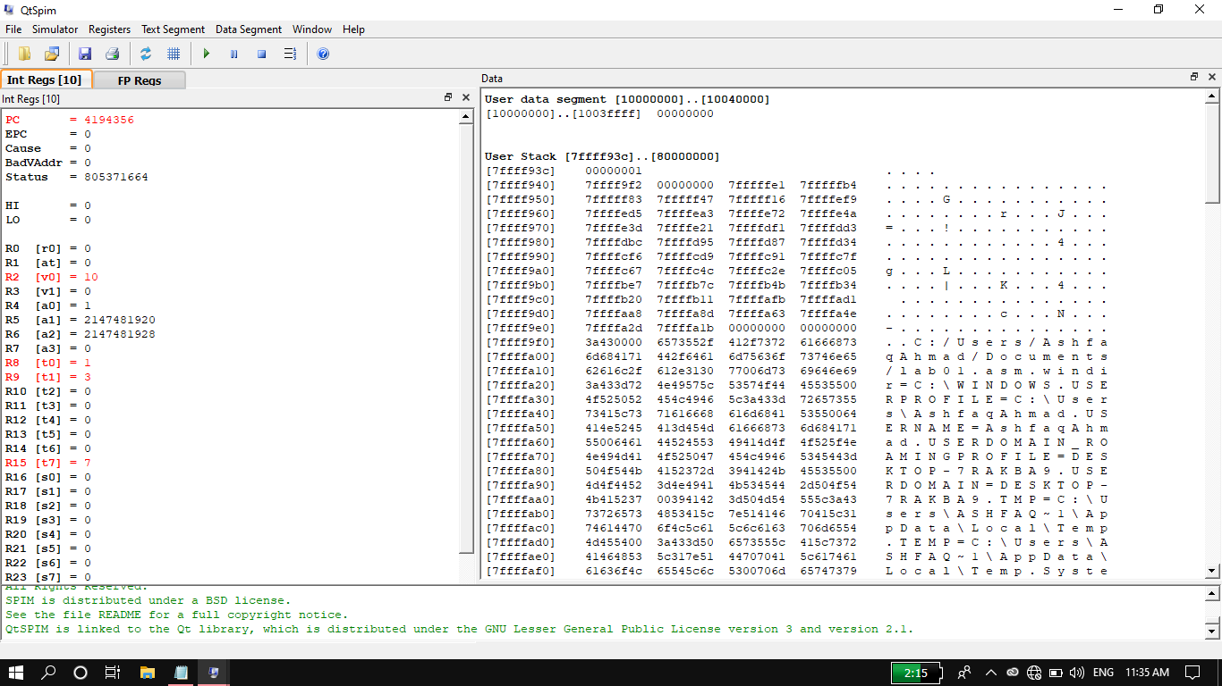

**Task 1(b):**

* **Create a program that take two integers and then find their sum.**

**Source code:**

.text

main:

li $t0,1 #li stand for load immediate. $ sign represent register

li $t1,3

li $t7,7

add $t4,$t0,$t7

li $v0,10 #v0 will contain any value. when it contain 10 its mean program terminate.

Syscall.

**Output:**

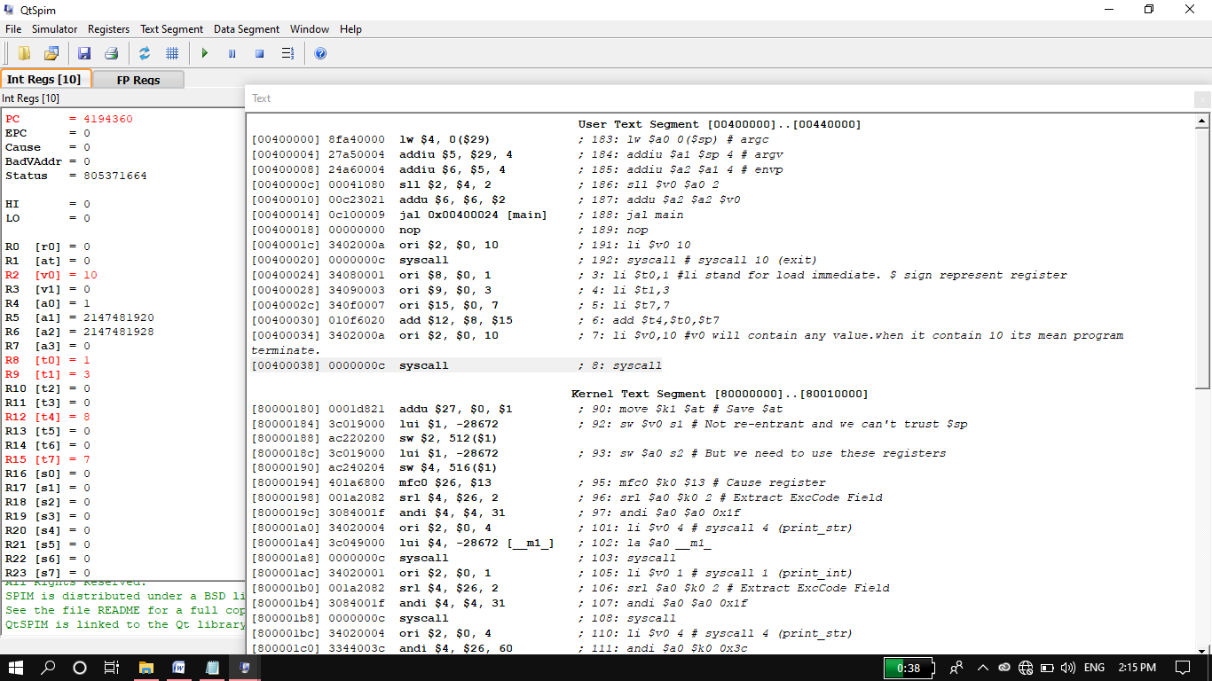

**Task 2:**

* **Create a program that take four integers and then find their sum.**

**Source code:**

.text

main:

li $t6,4

li $t5,3

li $t4,2

li $t3,1

add $t8,$t6,$t5 #add instruction will always have two source (input) and one destination (output).

add $t1,$t4,$t3

add $t7,$t8,$t3

li $v0,10

syscall

Output:

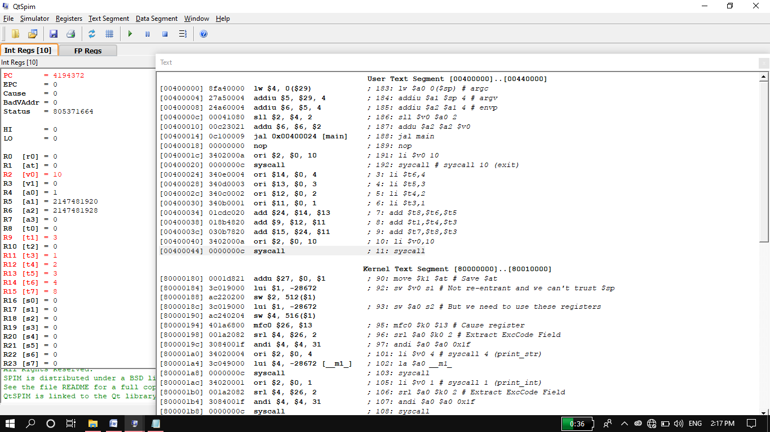

**Task 3:**

* **Create a program that take two integers from the user during run time and then find their sum.**

**Source code:**

.text

main:

li $v0,5 # when v0 contain 5 its mean it ask something from user.

syscall

move $t0,$v0 #we will move data from v0 register to $t0 register for next input.

li $v0,5

syscall

move $t1,$v0

add $t2,$t0,$t1

li $v0,10

syscall

Output:

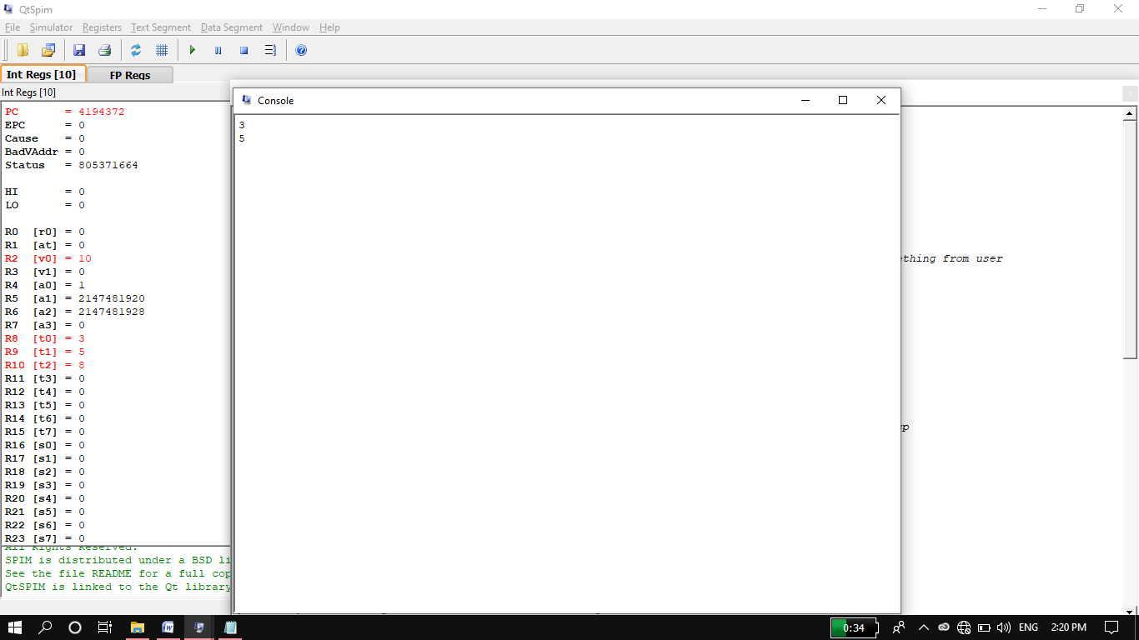

**Task 4:**

* **Create a program that take two integers from the user during run time and then find their difference.**

**Source code:**

.text

main:

li $v0,5

syscall

move $t0,$v0

li $v0,5

syscall

move $t1,$v0

sub $t2,$t1,$t0

li $v0,10

syscall

Output:

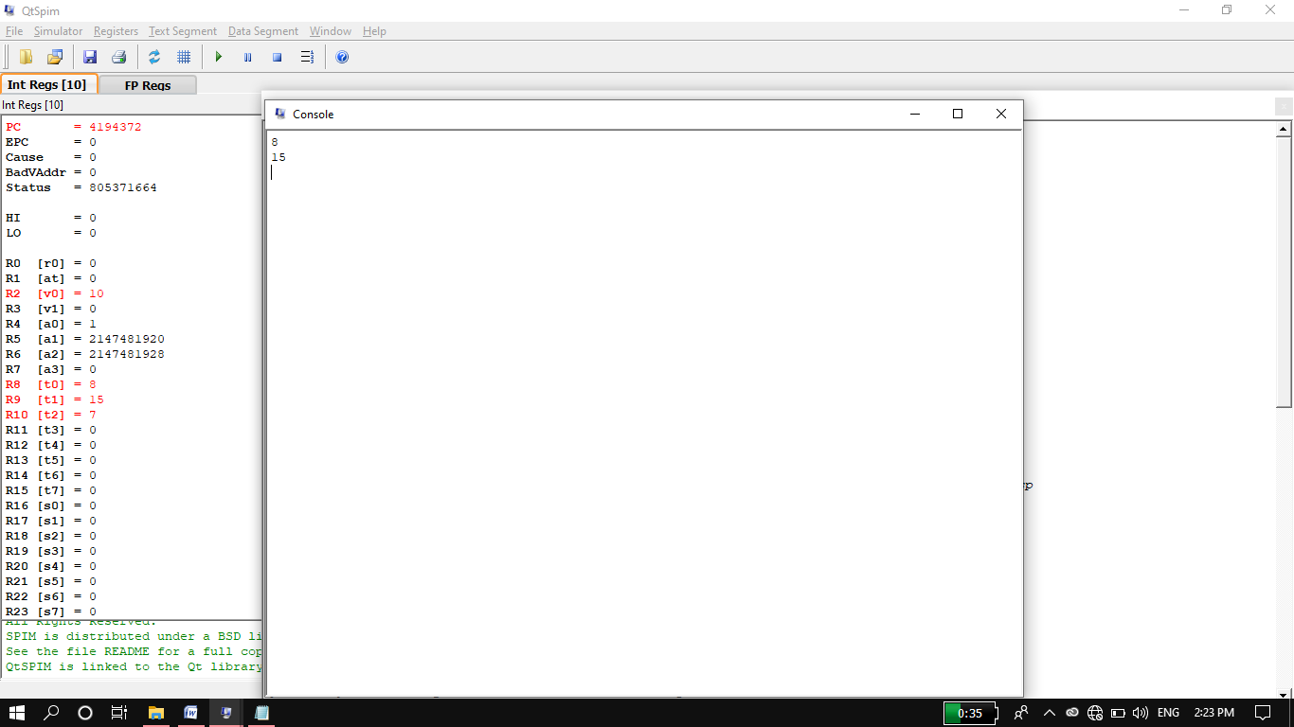

**Task 5:**

* **Create a program that take five integers from the user and perform the following operation. The output must display in console window.**
* **S7=S6+S4-S5-S2+S0**

**Source code:**

.text

main:

li $v0,5 #when we input data it store in v0.

syscall

move $t0,$v0 #we move data from a0 to register for the next input.

li $v0,5

syscall

move $t2,$v0

li $v0,5

syscall

move $t5,$v0

li $v0,5

syscall

move $t4,$v0

li $v0,5

syscall

move $t6,$v0

add $s1,$t6,$t4

add $s2,$s1,$t2

add $s3,$t5,$t0

sub $s7,$s2,$s3

#move $a0,$s7 # this movement is for displaying data on console window. if we donot move data to ao then data such data will not display on console window.

li $v0,1 # if v0 contain 1 it will display the data in register a0.if a0 is empty then by default 1 is assigned to a0 during runtime and displayed on console window.

syscall

li $v0,10

syscall

Output:

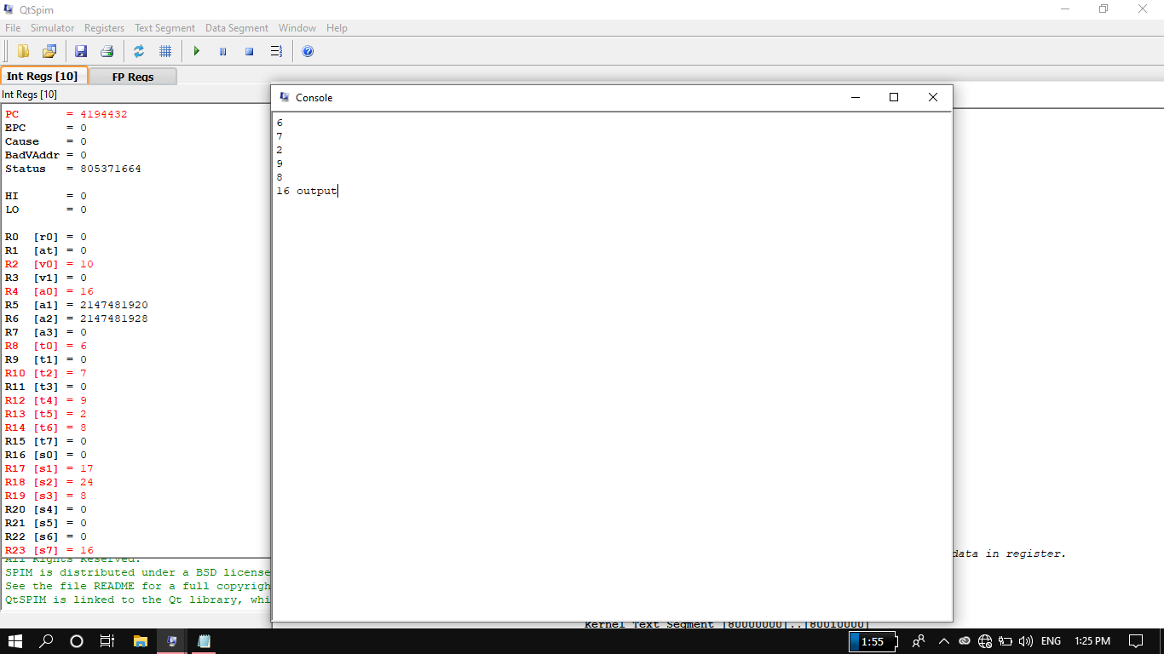

The End